STITCH & FLIP PLACEMAT
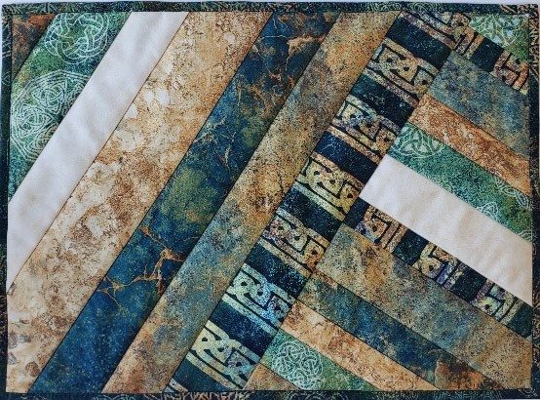

Project Requirements:

6-8 WOF strips of coordinating fabric ranging in width from 1” to 3”
1 – 14” x 20” piece of backing fabric
1 – 14” x 20” of batting (fusible or spray basted to the backing fabric) 2 – 2” strips of coordinating fabric for binding

SUPPLIES:
- Sewing machine in good working order with manual, presser feet, attachments, and foot controller.
- ¼” foot to fit your machine
- Sewing Machine Needles – Microtex (Sharp) 80/12 or Quilting 75/11
- Rotary cutter – 45mm. These are really sharp, so the preferred one has an ergonomic handle. The blade retracts when you are not using it.
- Quilting rulers – 8 ½”x24” if you are buying a new one 6 ½” square
- Rotary Cutting Mat (self-healing) – 18”x24” or larger
- Cotton thread in a neutral colour – Gray or beige 50 weight. Both Aurifil (2ply) and Gutterman(3 ply) will work. The Aurifil does not take up as much room in the seam.
- Pins – fine with glass heads. I like Clover Silk Pins as they easily go through the fabric
- Seam ripper
- Tailors Awl – it needs a sharp point as it takes the place of your finger when you get to the end of the seam
- Pencils for marking lines on fabric –white (Fons & Porter) or Frixion pens
- Small scissors or thread snips
- Mary Ellens Best Press – unscented
- Notebook and pen

